Data Originally Organized by Cages:
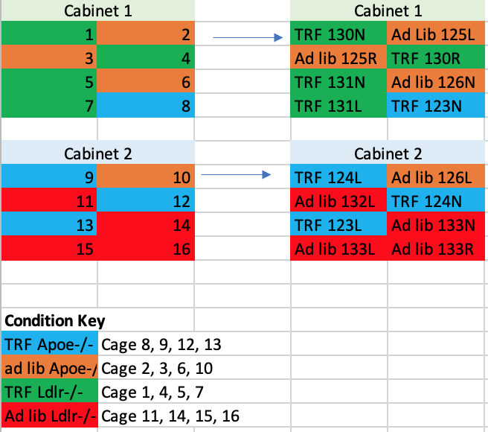
- ApoE ad lib: Cages 2, 3, 6, 10
- ApoE TRF: Cages 8, 9, 12, 13
- Ldlr ad lib: Cages 11, 14, 15, 16
- Ldlr TRF: Cages 1, 4, 5, 7

Renaming cages to match hfdneuro file:
Animal # | Original Metabolic Cage # | Experimental Group
1 | 2 | ApoE ad lib
2 (MUST EXCLUDE—MOUSE 125R) | 3 | ApoE ad lib
3 | 6 | ApoE ad lib
4 | 10 | ApoE ad lib
5 | 8 | ApoE TRF
6 | 9 | ApoE TRF
7 | 12 | ApoE TRF
8 | 13 | ApoE TRF
9 | 11 | Ldlr ad lib
10 | 14 | Ldlr ad lib
11 | 15 | Ldlr ad lib
12 | 16 | Ldlr ad lib
13 | 1 | Ldlr TRF
14 | 4 | Ldlr TRF
15 | 5 | Ldlr TRF
16 | 7 | Ldlr TRF

Notes:
- Must exclude animal 2 (mouse 125R death)

- Measurements that are different/missing in my dataset compared to Erica’s dataset:
  - Erica’s datapoints are for every 10 minutes, while mine are for every 5 minutes!
  - Only "foodup” for intake, no “FoodInA” and “FoodInB” – placed food intake into FoodInA column
  - Only “pedmeters”, no separate columns for “PedMeters_Mnz”, “PedMeters_M”, and “PedMeters_R” placed pedmeters into “PedMeters_M” column
  - Only “allmeters”, no separate columns for “AllMeters_M” and “AllMeters_R” placed allmeters into “AllMeters_M” column
  - Only “wheelmeters”, no separate columns for “WheelMeters_M”, “WheelMeters_R”, and “WheelSpeed_Mnz”” placed wheelmeters into “WheelMeters_M” column

- Measurements that are completely absent in my dataset and not mentioned above:
  - H2_M
  - VOC_M
  - EnviroTemp_M
  - EnviroRH_M
  - EnviroBP_M
  - EnviroLightlux_M
  - EnviroOccupancy_M
  - EnviroSound_M

- Measurements that are present in my dataset but not in Erica’s dataset:
  - Body mass (g) included at end of dataset

- X BREAK for animal 8 seems to have been broken (exclude)
- Total 4 days for animal 1, rows A2:A1154

